Image Release Form
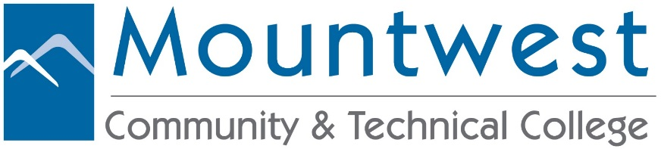
I grant permission to be photographed, filmed or videotaped by Mountwest Community & Technical College to be used in any medium Mountwest sees fit. This includes but is not limited to the use of my name, image or likeness for television, Web site, radio and/or social media in connection with educational, promotional and/or fundraising materials for Mountwest Community & Technical College. I also understand and agree that NO COMPENSATION OF ANY FORM will be given for my participation.

Course Name/No.: ______________________________________________________________

Professor Name: ________________________________________________________________

Signature: __________________________________________ Date: __________________

Student Printed Name ​ Student Signature

_________________________________ __________________________________
_________________________________ __________________________________
_________________________________ __________________________________
_________________________________ __________________________________
_________________________________ __________________________________
_________________________________ __________________________________
_________________________________ __________________________________
_________________________________ __________________________________
_________________________________ __________________________________
_________________________________ __________________________________
_________________________________ __________________________________

