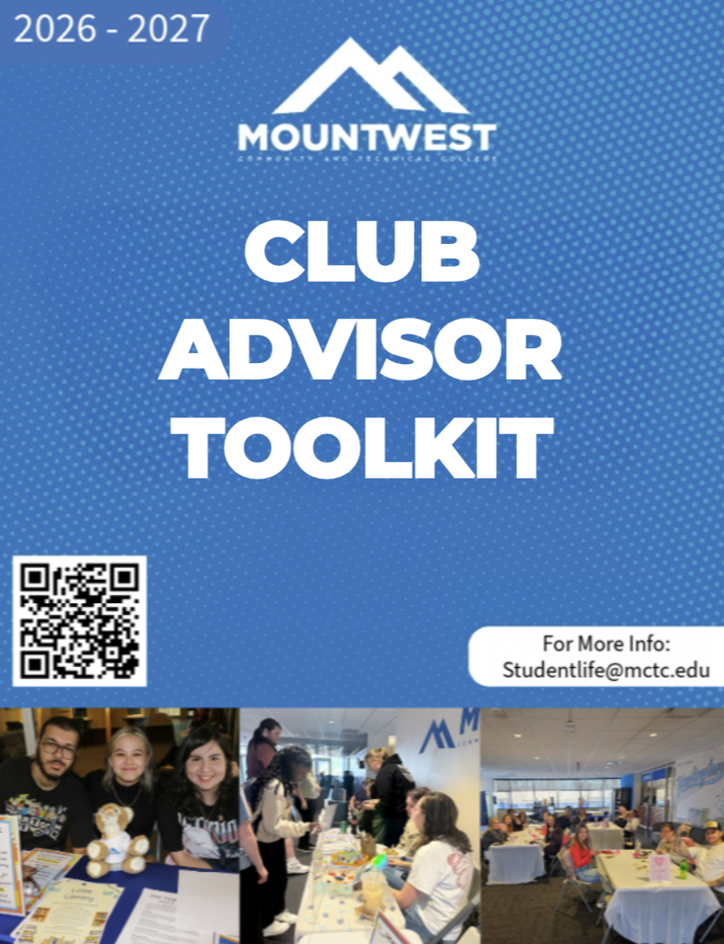Table of Contents
Getting Started
Introduction………………………………………………………….......……….....….….2
Mountwest Mission, Vision, and Student Organization Mission ………………..……….2
Advisor Essentials
Advisor Responsibilities ………………………………...…………….….….….…..……2
Advisors Role .….…….…….……….……..…………....……...………………..….……3
Keeping Your Club Active …………..……………………………………………...……4
Loss Of Recognition ……………………………………………………...………………5
Managing Your Organization
Events Made Easy ………………………………………….……………….……….……6
Money & Fundraising …………………………………………...……….……………….7
Club Bank Accounts ………………………………………….……….………………….7
Working With Student Leaders ………………………………………..………………....9
Best Practices for Advisors ………………………………….………………………..…10
Resources
Resources & Frequently Asked Questions ……………………………………….……..11
Frequently Used Forms ……………………………..……………………………,……..11
Need Assistance? ……………………………………….………………………,………12
Appendices
Intent to Organize Form ………………………………………………………...…….…13
New Chartering Form …………………………………………………..……………….14
Event Request Form ………………………………………………………………..……15
Club Fund Request Form ……………………………………………………….……….16
Outside Donation Request Form ……………………………………………….………..17

Introduction
Thank you for choosing to make a difference in the lives of Mountwest students by serving as a student organization advisor. Advisors are among the most influential mentors on campus, helping students discover their leadership potential, develop valuable life skills, and create memorable experiences outside the classroom. This toolkit is intended to make your role as an advisor easier by providing a quick reference to the resources, expectations, and procedures that support successful student organizations. Our hope is that this guide equips you with the tools you need while allowing students to take ownership of their organizations and grow through their experiences.

Mountwest Mission Statement
Mountwest empowers students to learn and lead in the community and in the workforce.

Mountwest Vision
Mountwest makes a positive impact on the lives of our students while providing them with the education and tools to prepare for their future. We inspire, support, and develop students to achieve goals, build positive relationships, and succeed in the workforce.

Mission for Student Organizations
Our mission for all student organizations is to ensure a positive atmosphere and welcoming environment to any student of any interest.

Advisor Responsibilities
Student organization advisors play an important role in the success of student organizations by serving as mentors, resources, and advocates for student leaders. Advisors help students develop leadership skills, navigate challenges, and ensure organizations operate in accordance with college policies and procedures. While advisors provide guidance and support, student organizations should remain student-led, allowing members to make decisions, organize activities, and gain valuable leadership experience.
As a student organization advisor, you are expected to:
- Serve as a mentor by providing guidance, encouragement, and leadership development opportunities while allowing students to take ownership of their organization.
- Promote student success by encouraging active participation, inclusion, collaboration, and a welcoming environment for all students.
- Support organizational planning by assisting officers with setting goals, planning meetings, developing events, and creating achievable objectives for the academic year.
- Attend meetings and events whenever possible to provide support, answer questions, and ensure activities are conducted safely and in accordance with college policies.
- Review and approve organizational expenditure when required and encourage responsible financial management in accordance with the Student Organization Handbook.
- Assist with event planning and risk management by ensuring required forms are submitted on time, College procedures are followed, and events provide a positive experience for participants.
- Maintain communication with the Student Engagement Coordinator regarding advisor changes, organizational concerns, leadership transitions, or questions related to college policies.
- Model professionalism and ethical leadership by demonstrating respect, integrity, accountability, and appropriate conduct while serving as a representative of Mountwest Community & Technical College.
- Encourage officer development by helping student leaders build communication, problem-solving, teamwork, and organizational skills that will benefit them beyond their college experience.

Advisor's Role
An advisor's responsibility is to guide, mentor, and support—not to manage the organization. Student organizations are designed to be student-led, providing members with opportunities to make decisions, solve problems, and develop leadership skills through hands-on experience. Advisors should encourage thoughtful decision-making, ask questions that help students evaluate their options, and provide recommendations when needed while allowing students to take responsibility for the organization's success.
Advisor Tip: The most successful advisors empower students to lead by asking guiding questions instead of providing all the answers. Allowing students to learn through experience builds confidence, accountability, and leadership skills.

Keeping Your Club Active
Ensure the club maintains active membership, holds regular meetings, participates in Club Crawl, hosts campus programming and service, keeps governing documents current, and attends Advisor/President meetings as described in the Student Organization Handbook.
It is required that Student Clubs/Organizations maintain:
  - Student Organizations must maintain a minimum of three (3) currently enrolled student members and one (1) active faculty or staff member.
  - (Any changes to membership or advisor status should be reported to the Student Engagement Coordinator)
  - Student Organizations are expected to participate in Club Crawl/Family Fun Night or other officially designated student involvement events each Fall and Spring semester unless otherwise approved by the Student Engagement Coordinator.
  - Organizations should actively recruit members and maintain a visible presence on campus.
  - On the third Wednesday of each month (excluding August, December, January, and May), a meeting will be held either in person or via Microsoft Teams to provide a monthly check-in regarding club progress, concerns, updates, and questions. In the event the Club Advisor can’t attend, then the club president or another designated officer may attend in their place. If they are unable to attend, then you must email the Student Engagement Coordinator immediately. The Student Body President and the Student Engagement Coordinator will be in attendance of these meetings. The dates are listed here, and the Student Engagement Coordinator will send out a reminder email as well.
    - September 17th
    - October 15th
    - November 19th
    - February 18th
    - March 18th
    - April 15th
  - Each recognized student organization must sponsor or participate in at least one campus-wide event and one service activity per semester that benefits the Mountwest community.
    - (Exceptions may be granted for organizations whose primary purpose or accreditation requirements differ from this expectation.)
  - Organizations should conduct meetings on a regular basis, with a minimum of one meeting per month during the fall and spring semesters.
  - Meeting schedules should be communicated to members and updated as needed.
  - Current copies of the organization’s Constitution, Bylaws, officer roster, advisor information, and any amendments must be submitted to the Student Engagement Coordinator.
    - (Any changes to governing documents or leadership should be reported within 30 days.)
  - Organizations must operate in accordance with all Mountwest Community & Technical College policies, including the Student Code of Conduct, Anti-Hazing Policy, financial guidelines, and event procedures.
  - Organizations are responsible for ensuring that all members conduct themselves in a manner that reflects positively on the College.

Loss of Recognition
An organization may be placed on probation, suspended, or have its recognition revoked if it:
- Fails to maintain the minimum membership or advisor requirements.
- Fails to meet participation or programming expectations without prior approval.
- Violates College policies or procedures.
- Engages in conduct that jeopardizes the safety or well-being of students or the campus community.
- Fails to comply with financial reporting or administrative requirements.
Whenever practical, organizations will receive written notice of deficiencies and be given an opportunity to correct them before recognition is revoked. In cases involving serious misconduct or immediate safety concerns, the College reserves the right to suspend or revoke recognition immediately.
Organizations that lose recognition may reapply during the following academic semester by submitting the required documentation and demonstrating compliance with college policies and procedures.

Events Made Easy
Submit Event Request Forms at least two weeks in advance, coordinate room reservations, marketing, food, volunteers, and complete post-event reflection.
Step-by-step timeline
4 Weeks Before
- Brainstorm ideas
2 Weeks
- Event Request Form
- Supplies
- Reserve space
- Marketing
1 Week
- Volunteer assignments
- Event material checklist
Day of Event
- Advisor checklist
- Run the event!
After Event
- Reflection
- Attendance
- Photos
- Assessment

List of Successful events:
-Bake Sale
-Car Wash
-Game Night
-Raffle Table
-Paint & Sip (non – alcoholic)
You can also partner with the Student Engagement Coordinator on any events just reach out prior to the event!

Money & Fundraising
Review budgets, approve expenditures, retain receipts, understand independent bank account expectations, and ensure fundraising follows College procedures.
Club Bank Accounts
Each club/organization has the option to have their own bank account. If the club/organization chooses to open the bank account, they will need to follow the Independent Funds Guidelines. This account should house only funds raised by the club/organization. The responsibility of those accounts’ rests solely with the students and the organization, not the College. Spending of said funds will need approval of the club/organization advisor.
- Process to Establish a New Bank Account for a Student Organization
  - The new student organization must be approved by the Student Engagement Coordinator.
  - The new student organization must supply the following information to the Vice President of Student Services PRIOR to creating a bank account:
    - IRS Tax Letter to indicate 501(c) (3) status
    - An established FEIN specifically for the organization
    - Signature of the advisor
    - Name of bank the account will be established at Chase Bank on 5th Ave.
  - The Vice President for Student Services and the Student Engagement Coordinator will retain this information for official records.
  - Once a bank account is created, the account information must be provided to the Vice President of Student Services and Student Engagement Coordinator in the form of an official statement from the bank.

- Use of Funds Guidelines
  - Student organizations may use funds raised by the organization with the approval of the organization advisor
  - In general, student organization funds should be spent on activities in the best interest of the student body
  - Funds MUST be deposited into the correct organization’s official account prior to the use of funds
  - Items prohibited from being purchased include:
    - Illegal substances or purchases
    - Alcohol, drugs, tobacco products including e-cigs
    - Lottery tickets or other forms of gambling
    - Weapons, firearms, or ammunition
    - Religious or political activities
      - Religious activity is defined as any activity that primarily promotes or manifests a particular belief in or about a deity or an ultimate reality
      - Political activity means doing something in active support of or opposition to a political party, candidate for partisan political office, or a partisan political group
    - Legal services of bail bond funds
    - Advisor-related purchases
    - Reimbursements of any kind

- Required Documentation and Reporting of Funds
  - Each quarter, financial statements of all student organizations must be submitted to the Vice President for Student Services and Student Engagement Coordinator. The Vice President for Student Services and Student Engagement Coordinator will review statements to ensure funds are being used appropriately.
  - The Vice President of Student Services and Student Engagement Coordinator will provide copies of the statements to the Business Office.
  - All receipts must be kept by the organization’s treasurer or advisor
  - If at any time, bank information for a student organization change, The Student Engagement Coordinator must be informed immediately

- Violations
  - Violations of these guidelines, as determined by the Vice President for Student Services and Student Engagement Coordinator, are subject to, but not limited to, the following actions:
    - The removal of the student organization Advisor
    - The closure of the student organization bank account
    - The disbandment of the organization

- Liability
  - The college is not liable for any purchases, overdrafts, or other financial activity conducted by student organizations via independent bank accounts.

If a club is not active for two semesters, shuts down, or fails to follow requirements, all funds need to be sent to the Student Engagement Coordinator and Vice President of Student Services, and the bank account will be closed. The remaining funds of the organization will be donated to the Foundation.

Working with Student Leaders
One of the most rewarding aspects of serving as a student organization advisor is the opportunity to help students grow into confident, capable leaders. Advisors play a critical role in mentoring officers by providing guidance, encouragement, and constructive feedback while allowing students to take ownership of their organization. Student organizations are intended to be student-led, and advisors should strive to create an environment where students are empowered to make decisions, solve problems, and learn from both their successes and challenges.
Advisors should encourage officers to establish goals, develop action plans, and delegate responsibilities among members. Leadership should be shared whenever possible, allowing each officer to contribute to the success of the organization rather than relying on one individual to carry the workload. By encouraging teamwork and accountability, advisors help students build valuable communication, organizational, and leadership skills that extend beyond the classroom.
When challenges arise, advisors should serve as coaches rather than decision-makers. Encourage students to discuss concerns openly, consider multiple solutions, and work collaboratively to resolve conflicts. Rather than solving problems for students, ask thoughtful questions that help them evaluate their options and make informed decisions. These experiences provide meaningful opportunities for personal growth and leadership development.
Regular communication with student officers is essential to maintaining a successful organization. Advisors are encouraged to meet with officers periodically to discuss upcoming meetings, events, organizational goals, and any concerns that may impact on the club's success. These meetings provide an opportunity to celebrate accomplishments, identify potential challenges early, and offer guidance before issues become larger concerns.
Above all, advisors should foster an environment that is welcoming, respectful, and inclusive. Every student should feel encouraged to participate, share ideas, and contribute to the organization's mission. By modeling professionalism, integrity, and respect, advisors help create a positive organizational culture where students feel supported, valued, and empowered to lead.
Best Practices for Advisors
- Encourage students to make decisions and take ownership of their organization while remaining available for guidance and support.
- Ask guiding questions rather than providing immediate solutions to help students develop critical thinking and problem-solving skills.
- Promote teamwork by encouraging officers to delegate responsibilities and involve members in planning and decision-making.
- Recognize and celebrate student achievements, milestones, and leadership growth throughout the academic year.
- Address conflicts early by encouraging respectful communication, active listening, and collaborative problem-solving.
- Help students learn from mistakes by treating challenges as opportunities for growth rather than failures.
- Maintain regular communication with organization officers and the Student Engagement Coordinator to ensure the organization remains informed and successful.
Advisor Tip: The most effective advisors don't lead the organization—they develop leaders who can. Your role is to empower students with the confidence, knowledge, and support they need to make decisions, overcome challenges, and create a successful organization.
Resources & Frequently Asked Questions
The Office of Student Engagement is committed to supporting student organization advisors and officers throughout the academic year. Whether you have questions about starting a new organization, planning an event, requesting funding, or interpreting College policies, assistance is always available. Advisors are encouraged to contact the Student Engagement Coordinator whenever guidance or clarification is needed.
Frequently Used Forms
The following forms are required for the operation of student organizations and can be obtained from the Office of Student Engagement or the Student Organizations webpage.
- Intent to Organize Form – Used by students wishing to establish a new student organization.
- New Chartering Form – Required to officially recognize a newly established organization.
- Event Request Form – Required for all club meetings, activities, fundraisers, and events held on or off campus. Forms should be submitted at least two weeks before the proposed event.
- Club Fund Request Form – Used to request financial assistance through the Office of Student Engagement for approved club activities and purchases.
- Outside Donation Request Form – Required before soliciting donations or conducting fundraising activities outside of the College.
Frequently Asked Questions
Who should I contact if I have questions about my organization?
Contact the Student Engagement Coordinator – Sorrellsr@mctc.edu for assistance with club recognition, policies, events, funding, leadership transitions, forms, or general student organization questions.
Am I expected to attend every meeting or event?
While attendance is encouraged whenever possible, advisors understand that work responsibilities may occasionally prevent participation. Advisors should maintain regular communication with student officers and remain informed about organizational activities.
Can students make decisions without the advisor?
Yes. Student organizations are designed to be student-led. Advisors should provide guidance and mentorship while allowing students to make informed decisions and develop leadership skills.
What if an organization is struggling or becomes inactive?
Reach out to the Student Engagement Coordinator as early as possible. Together, strategies can be developed to improve recruitment, officer engagement, and organizational success before recognition is affected.
Who approves purchases or fundraising activities?
Advisors should review expenditures and ensure all fundraising and purchasing activities follow the procedures outlined in the Student Organization Handbook and applicable College policies.
Need Assistance?
The Office of Student Engagement is here to support both advisors and student leaders. Never hesitate to ask questions or seek guidance. we are committed to helping every student organization provide meaningful opportunities for leadership, service, and campus engagement.

Contact the Office Of Student Life:

Jackson Sorrells
Coordinator of Student Engagement & Leadership
Mountwest Community & Technical College
________________________________________
304-710-3375
Sorrellsr@mctc.edu
One Mountwest Way, Huntington, WV 25701

 Office of Student Activities
Intent to Organize Form

Date of Application: ________ Proposed Name of Club: ________________________
Student Organizer: _______________________________________________________
Student MCTC Email: __________________________________________@mctc.edu

Describe in detail the club’s purpose:
Describe the “need” on campus which this club will fill:

What is the proposed schedule of the meetings? (Weekly, monthly, etc.) __________________
Advisor’s Name: ___________________________________
Advisor’s MCTC email: _____________________________@mctc.edu
After the end of the semester, you will need to complete the New Chartering Form for your club to become official. You have the semester to gather members and to advertise your club. You will be responsible for sending the copies of the club’s constitution, bylaws and membership list by the end of the semester. You must have 3 active members of the club and 1 advisor, that is faculty or staff. By signing this, you understand the requirements of student organizations and will complete those necessary requirements.
Student Organizer Signature: _________________________________ Date: _________
Advisor Signature: __________________________________________ Date: __________

Office of Student Activities
New Chartering Form
Name of Student Organization: ____________________________________________________________
Advisor(s): __________________________________________________

Members
President: _____________________________________________
MCTC Email: ________________________________@mctc.edu
Vice President: _________________________________________
Secretary: _____________________________________________
Other members: ________________________________________________________________________________________________________________________________________________________________________________________________________________________
Does your organization have a bank account? If yes, please list the information below:
FEIN/Tax ID Number: ________________________________________________
Names on the account: ________________________________________________
By signing this form, you have read the Student Organization Handbook and are aware of all policies for student organizations: You understand that you are responsible for your organization and failure to follow the requirements, the organization is subject to suspension. Please turn in this form with your organization’s constitution, bylaws, and purpose statement of your organization.

Student Organization President_____________________________ Date:_________
Advisor: ______________________________________________ Date:_________
 Office of Student Activities

Event Request Form
Club Information
Name of Club: _______________________ Club Advisor:____________________________
Club President: ______________________________
Event Information
Name of Event/Activity: _________________________ Desired Date of Event: ___________
Estimated Start Time: ___________________ Estimated End Time: _________________
Event Type: On Campus Off Campus Room Request: _____________
Will there be food at this event? YES NO
Will you be needing advertisements? (i.e., posters, social media posts, etc.) YES NO
*If yes, please let Student Engagement Coordinator know 2 weeks in advance so that all proper channels are notified.
Please state your purpose of this event:

By signing this form, you accept responsibility for this event and understand that you are to complete this form within 2 weeks of the event. You are responsible for being present at this event and you must abide to the rules and regulations of the college.
Name:_________________________ Signature: _________________________ Date: ________
College Email: _________________________@mctc.edu Phone Number: _________________
Club Advisor Signature: _______________________________________ Date: _____________

Office of Student Activities

Club Fund Request Form
Club Information
Name of Club: ____________________________________________________
Club Advisor: ____________________________________________________
Club President:____________________________________________________

Please specify how much funding you are requesting:
Item | Estimated Cost
Please explain the purpose of purchasing these items:

Please send this form 2 weeks in advance of when you need these items. The Student Engagement Coordinator will contact you to let you know if your request is approved or denied.
Student Organizer Signature: ___________________________________ Date: ____________
Advisor Signature: ___________________________________________ Date: ____________
Student Engagement Coordinator Signature: __________________________________
Approved: Denied: Date: ___________

Office of Student Activities

Outside Donation Request Form
Club Information
Name of Club: __________________________ Club Advisor: __________________________
Club President: __________________________
Event Information
Name of Event/Activity: __________________________ Desired Date of Event: ____________
Where will this event take place? ___________________________________________________
Will you be needing advertisements? (i.e., posters, social media posts, etc.) YES NO
*If yes, please let the Student Engagement Coordinator know 2 weeks in advance to create your advertisements.
What will you be selling? _________________________________________________________
Please state why you are raising the funds outside of the college:

By signing this form, you accept responsibility for this event and understand that you are to complete this form within 2 weeks of the event. You are responsible for being present at this event and you must abide by the rules and regulations of the college. Please know that this is subject to approval of the Vice President of Institutional Advancement.
Name:_________________________ Signature: ________________________ Date: _________
College Email: _________________________@mctc.edu Phone Number: _________________
Club Advisor Signature: _______________________________________ Date: ______________

