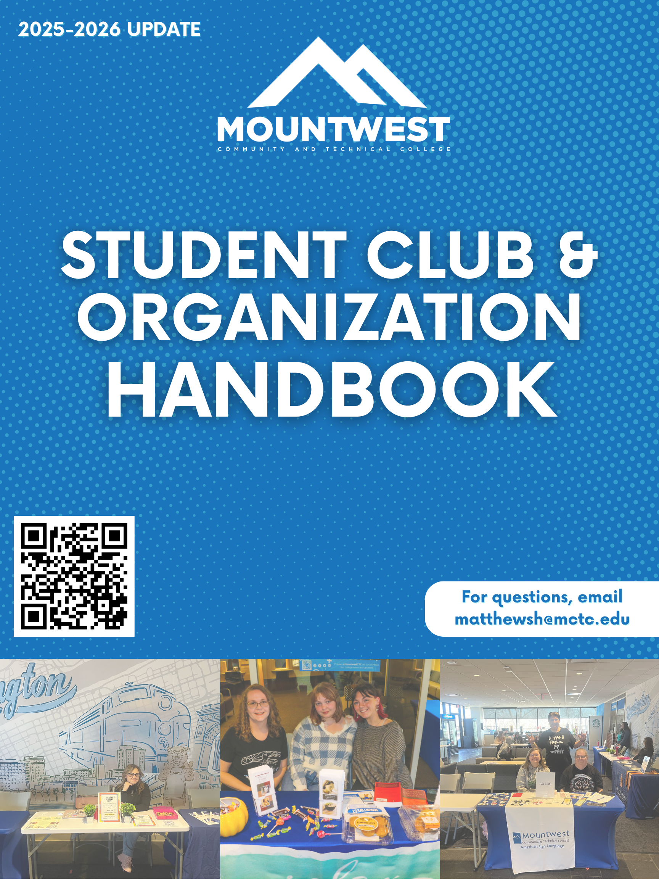

Table of Contents

Introduction 2
Student Code of Conduct 2
Anti-Hazing Policy 2
Mountwest Mission Statement 3
Mission for Clubs 3
Intent to Organize 4
How to Start a Club 4
Maintaining Recognition 4
Requirements of Clubs 5

Clubs Finances 6
Club Bank Accounts 6
How to obtain and EIN Number 7
Maintaining Club Funds 8
Fundraising 8
Requesting Club Funds 8
Club Events 9
Requirements for Club Events 9
Marketing for Clubs 9

Forms

Introduction

Student Code of Conduct
In general, college jurisdiction and disciplinary sanctions will be applied to incidents and conduct which occur on the college campus or at college sponsored events or activities. However, jurisdiction and disciplinary sanctions may also be applied at the discretion of the college to conduct that occurs off campus and which adversely affects the college. Visitors on campus are also expected to abide by the prohibitions pertaining to student conduct and by all local, state and federal laws and ordinances. Visitors failing to do so may be asked to leave campus and may be declared persona non grata. The following prohibitions pertaining to student conduct are considered essential to the educational mission and community life of the college.
- Behavior which disrupts the learning environment.
- Use, possession, and/or distribution of weapons, firearms, firecrackers, explosives and/or chemicals.
- Use or possession of illegal or controlled drugs and/or alcohol.
- Gambling
- Abusive and/or disorderly behavior.
- Deliberate destruction and/or abuse and misuse of college property or facilities.
- Theft from an individual, organization or agency, and/or division of the college.
- Assault and battery, threats of violence, and/or intimidation.
- Written, verbal, sexual and/or physical intimidation or harassment.
- Violations of the college’s Acceptable Use Policy for computer access and use.
- Failure to comply with reasonable requests of a college representative.
- Any conduct which violates the laws of the United State, the State of West Virginia, Cabell County, and/or the City of Huntington.

This list of prohibitions is not a full listing of unacceptable behavior in a college community. Other unacceptable behavior may also result in disciplinary action. Academic dishonesty (such as cheating and plagiarism) or classroom behavior considered detrimental to the teaching-learning process will be addressed by the college’s academic offices. A full statement on student academic dishonesty can be found in the Academic Definitions & Procedures section of the catalog.
Anti-Hazing Policy
Mountwest Community & Technical College prohibits hazing as defined in this policy. The College will investigate and respond to all reports of hazing as outlined in this policy. An organization consists of a number of persons who are associated with each other and have registered with the College as a student organization (such as clubs, and fraternities and sororities) are subject to this policy.
Hazing is defined as an act or coercing another, including the victim, to do any act of initiation into any student organization or any act to continue/reinstate membership in or affiliation with any student or organization that create a substation rick of causing mental or physical harm to any person. This includes:
- whipping, beating, striking, electronic shocking, placing of a harmful substance on someone’s body, or similar activity;
- causing, coercing, or otherwise inducing sleep deprivation, exposure to the elements, confinement in a small space, extreme calisthenics, or other similar activity;
- causing, coercing, or otherwise inducing another person to consume food, liquid, alcohol, drugs, or other substances;
- causing, coercing, or otherwise inducing another person to perform sexual acts;
- any activity that places another person in reasonable fear of bodily harm through the use of threatening words or conduct;
- any activity against another person that includes a criminal violation of local, State, Tribal, or Federal law; and
- any activity that induces, causes, or requires another person to perform a duty or task that involves a criminal violation of local, State, Tribal, or Federal law.
Hazing is a serious offense of the College "Student Code of Conduct" and, therefore, is subject to the full range of sanctions (reprimand, disciplinary probation, suspension, and expulsion). In addition, other educational activities may be required as conditions of the sanction. An individual, organization, or group may be subject to other outcomes in accordance with the applicable outside constituents, academic processes, group in which the student is involved, or their governing bodies. The College has the right to act regardless of the actions of a governing body.
To submit a hazing report, please email pellr@mctc.edu or contact 304-710-3499.

Mountwest Mission Statement
Mountwest empowers students to learn and lead in the community and in the workforce.
Mountwest Vision
Mountwest makes a positive impact on the lives of our students while providing them with the education and tools to prepare for their future. We inspire, support, and develop students to achieve goals, build positive relationships, and succeed in the workforce.
Mission for Student Organizations
Our mission for all student organizations is to ensure a positive atmosphere and welcoming environment to any student of any interest.

Intent to Organize

How to Start a Club
To be considered a club/organization, you need to submit an Intent to Organize Form to the Office of Student Life. The form is available in the Student Services Once Stop, on the Student Organizations Page on the main website, or you can email Hannah Matthews for a copy of the form. If your organization is approved, then you will have temporary ability to:
- Hold and advertise organization meetings
- Recruit new members
- Reserve college space for events
Once you have the required items on the Intent to Organize form, then you will need to create your organizations Constitution and bylaws and submit it with the form. We want to keep all records of your organization in case of admin change, advisor change, or officer changes that can cause loss of paperwork. Failure to submit all documents will pause your organization’s creation.
Attendance of Club Advisor/President Meetings:
Each 3rd Wednesday, (excluding August, December, January, and May) there will be a meeting scheduled on Teams/In person so have a monthly check in to see how the club is doing, any concerns, general updates and questions. In the event the Club Advisor can’t attend, then the club president or someone of that equivalent will attend in their place. If they are unable to attend, then you must email the Student Engagement Coordinator immediately. The Student Body President and the Student Engagement Coordinator will be in attendance of these meetings. The dates are listed here and the Student Engagement Coordinator will send out a reminder email as well.
- September 17th
- October 15th
- November 19th
- February 18th
- March 18th
- April 15th

Maintain Recognition
We want to make sure that each organization is recognized by the college and advertised on our website. All organizations, excluding honor societies, is a privilege and the Office of Student Life has the right to either suspend the organization or dismiss the organization if they are not maintaining the following:
- Participate in Club Crawl every fall and spring semester.
- Have one campus wide event each semester.
- Have meetings often (at least one meeting once a month).
- Send in ANY changes to club constitution or bylaws to the Student Engagement Coordinator.
- Advertise your organization on designated tables with up-to-date information.
Organizations can lose recognition status by, also, the following:
- Inappropriate behavior by club/organization members reported to Student Engagement Coordinator by any staff, faculty, or student.
- Inappropriate behavior by club/organization members during any events.
- Violation of Mountwest Community & Technical College policies and procedures.
If a club/organization is suspended, they may reapply for recognition the following semester. The Application for Recognition will need to be filled out and submitted to the Student Engagement Coordinator.
Requirements of Club
In order to start a new student club or organization, students will need to discuss their plan with the Student Engagement Coordinator. They will provide the students with the following information:
- Charting Form: This will be completed each year for every club/student organization. The Student Engagement Coordinator will provide the club advisor with the form and any other information the advisor will have. This form is designated to keep track of each club/organization on campus year to year.
- Club/Organization Advisor: Every club/organization MUST have an advisor. The advisor must be employed at Mountwest Community & Technical College and be either a faculty member or staff member. The advisor must be willing to donate their times to help see of the club/organization each academic year. An advisor’s term will be for one academic year. If they choose to continue advising the club/organization they are a part of, then no other action will be taken. If the advisor chooses to leave the club/organization after the academic year, then they MUST notify the Student Engagement Coordinator.
- Members: For a club to be considered, there must be 3 members to be recognized. These members must be full or part time students at Mountwest Community & Technical College.
- Develop a Constitution & Bylaws: Once a club as three members and an advisor, a constitution must be written or one may adopt the standard sample that is provided by the Student Engagement Coordinator. The constitution can be as detailed as the members want it to be. Bylaws will be need to be provided with the constitution to the Student Engagement Coordinator.
Once all of this is completed, information will be turned into the Student Engagement Coordinator for approval. Incomplete forms will not be reviewed. Forms will be available on MCTC’s website, in the Student Services One Stop, or provided by the Student Engagement Coordinator.

Club Finances

Club Bank Accounts
Each club/organization has the option to have their own bank account. If the club/organization chooses to open up the bank account, they will need to follow the Independent Funds Guidelines. This account should house only funds raised by the club/organization. The responsibility of those accounts rests solely with the students and the organization, not the College. Spending of said funds will need approval of the club/organization advisor.
- Process to Establish a New Bank Account for a Student Organization
  - The new student organization must be approved by the Student Engagement Coordinator.
  - The new student organization must supply the following information to the Vice President of Student Services PRIOR to creating a bank account:
    - IRS Tax Letter to indicate 501(c) (3) status
    - An established FEIN specifically for the organization
    - Signature of the advisor
    - Name of bank the account will be established at Chase Bank on 5th Ave.
  - The Vice President for Student Services and the Student Engagement Coordinator will retain this information for official records.
  - Once a bank account is created, the account information must be provided to the Vice President of Student Services and Student Engagement Coordinator in the form of an official statement from the bank.

- Use of Funds Guidelines
  - Student organizations may use funds raised by the organization with the approval of the organization advisor
  - In general, student organization funds should be spent on activities in the best interest of the student body
  - Funds MUST be deposited into the correct organization’s official account prior to the use of funds
  - Items prohibited from being purchased include:
    - Illegal substances or purchases
    - Alcohol, drugs, tobacco products including e-cigs
    - Lottery tickets or other forms of gambling
    - Weapons, firearms, or ammunition
    - Religious or political activities
      - Religious activity is defined as any activity that primarily promote or manifests a particular belief in or about a deity or an ultimate reality
      - Political activity means doing something in active support of or opposition to a political party, candidate for partisan political office, or a partisan political group
    - Legal services of bail bond funds
    - Advisor-related purchases
    - Reimbursements of any kind

- Required Documentation and Reporting of Funds
  - Each quarter, financial statements of all student organizations must be submitted to the Vice President for Student Services and Student Engagement Coordinator. The Vice President for Student Services and Student Engagement Coordinator will review statements to ensure funds are being used appropriately.
  - The Vice President of Student Services and Student Engagement Coordinator will provide copies of the statements to the Business Office.
  - All receipts must be kept by the organization’s treasurer or advisor
  - If at any time, bank information for a student organization changes, Student Engagement Coordinator must be informed immediately
  - If a club is not active for two semesters, shuts down, or fails to follow requirements, all all funds need to be sent to the Vice President of Student Services and the bank account should be closed.

- Violations
  - Violations of these guidelines, as determined by the Vice President for Student Services and Student Engagement Coordinator, are subject to, but not limited to, the following actions:
    - The removal of the student organization Advisor
    - The closure of the student organization bank account
    - The disbandment of the organization

- Liability
  - The college is not liable for any purchases, overdrafts, or other financial activity conducted by student organizations via independent bank accounts.

If a club is not active for two semesters, shuts down, or fails to follow requirements, all funds need to be sent to the Student Engagement Coordinator and Vice President of Student Services and the bank account will be closed. The remaining funds of the organization will be donated to the Foundation.

How to obtain and EIN Number to open a club bank account
Since the College is a public-state agency, the student club or organization cannot use the EIN of the College, its non-profit or tax-exempt statuses. It is recommended that student clubs or organizations wishing to have their own bank account setup the account with their own EIN. This keeps the President, Treasurer, or Advisor from being required to associate their Social Security Number with the club’s or organization’s account. However, the account must be disclosed to both the Office of Business Services and the Office of Student Services.

Basically, the financial, tax, and legal activities of the student organization is primarily the responsibility of its’ members; and, personal account(s) of members to manage the club’s or organization’s affairs should not be used.

An EIN (Employer Identification Number) can be obtained from the IRS (Internal Revenue Service) by visiting Apply for an Employer Identification Number (EIN) Online | Internal Revenue Service (irs.gov). Obtaining an EIN does not mean a registered club or organization has tax-exempt status. A student club or organization is NOT considered tax-exempt by the IRS unless they apply for such status. The IRS has established eligibility criteria for varying kinds of non-profit organizations which can be reviewed. IRS Publication 557 (https://www.irs.gov/pub/irs-pdf/p557.pdf) provides a description of the various types of 501(c) non-profit organizations.

Maintaining Club Funds
Any funds that the student organization has raised for their club is not the responsibility of the College. It is solely up to the organization how they handle the funds. The club advisor or appointed student treasurer should be keeping an update document of the funds that the club has raised or spent.
The College is not responsible for any lost funds of the club. If you are needing any guidance, please contact the Student Engagement Coordinator.

Fundraising
Each club is allowed to participate in fundraising. This would require an Event Request Form to be filled out to be submitted to the Student Engagement Coordinator. The club/organization must notify the Student Engagement Coordinator two weeks before proposed date.
In the event that a club/organization wants to have outside fundraising event, they must fill out an Outside Donation Request Form. This will be looked over by the Student Engagement Coordinator, Vice President of Student Services, and the Vice President of Institutional Advancement. This form must be turned in 2 weeks prior to the proposed date of event.

Requesting Club Funds
The Office of Student Life has funds set aside each year for active clubs to request. If any club/organization are not keeping up with their active status, then they will not be allowed to request club funds.
Total amount that a club/organization can request for the year is $300.00. Once the club/organization has requested the make, they are no longer able to make a request for more funds. To request funds, each club/organization will need to fill out a Club Fund Request Form. This form can be found on the MCTC website under the Student Organization page, it can be picked up at the Student Services One Stop, or it can be requested from the Student Engagement Coordinator via email.
Any funds that are given to the club cannot be used for person use. These funds will be used for the club/organization or student body.

Club Events

Requirements for Club Events
Events that club/organizations have are a privilege. We want to ensure that all students are safe and following directions to have a great event. Club/Organizations must fill an Event Request Form 2 weeks before proposed event. This will give the Office of Student Life amble time to create any marketing materials that might be requested.
If the Event Request Form isn’t turned into the Student Engagement Coordinator or if the form is turned in with limited time left, the request will be denied. All sections will need to be completed on the form. If the form is incomplete, it will not be reviewed. The Student Engagement Coordinator will contact the President and the club/organization advisor if event is approved or denied.

Marketing for Clubs
Students are allowed to make their own marketing materials to distribute on campus. Flyers will need to be given to the Student Engagement Coordinator to post on the Office of Student Services & Student Life Facebook Page. If the club/organization do not make their own marketing materials, they will need to request them from the Student Engagement Coordinator. This will be an option on the Event Request Form. Please allow 2 weeks for the marketing material to be created.
If the club/organization wants to advertise to the community, they will need to contact Karen Horner for further advertisement.

Forms
 Office of Student Activities
Intent to Organize Form

Date of Application: __________________ Proposed Name of Club: ________________________
Student Organizer: ______________________________________________
Student MCTC Email: _____________________________@mctc.edu
Describe in detail the club’s purpose:

Describe the “need” on campus which this club will fill:

What is the proposed schedule of the meetings? (Weekly, monthly, etc.) ________________________
Advisor’s Name: _____________________________________
Advisor’s MCTC email: _____________________________@mctc.edu
Advisor’s Office Location: _______
After the end of the semester, you will need to complete the New Chartering Form for your club to become official. You have the semester to gather members and to advertise your club. You will be responsible for sending the copies of the club’s constitution, bylaws and membership list by the end of the semester. You must have 3 active members of the club and 1 advisor that is faculty or staff. By signing this, you understand the requirements of student organizations and will complete those necessary requirements.
Student Organizer Signature: __________________________________________ Date: __________
Advisor Signature: ________________________________________________ Date: _____________
Office of Student Activities
New Chartering Form
Name of Student Organization: __________________________________________________________
Advisor(s): ________________________________________________________

Members
President: _________________________________________
MCTC Email: ________________________________@mctc.edu
Vice President: _________________________________________
Secretary: _____________________________________________
Other members: ________________________________________________________________________________________________________________________________________________________________________________________________________________________________________________________________________________________________________________________
Does your organization have a bank account? If yes, please list the information below:
FEIN/Tax ID Number: ________________________________________________
Names on the account: ______________________________________________

By signing this form, you have read the Student Organization Handbook and are aware of all policies for student organizations: You understand that you are responsible for your organization and failure to follow the requirements, the organization is subject to suspension. Please turn in this form with your organization’s constitution, bylaws, and purpose statement of your organization.
_________________________________________ ___________________
Student Organization President or Overseer Date
_________________________________________ ___________________
Advisor Date
 Office of Student Activities

Event Request Form
Club Information
Name of Club: ____________________________ Club Advisor: ______________________________
Club President: ______________________________
Event Information
Name of Event/Activity: ____________________________ Desired Date of Event: ___________
Estimated Start Time: ___________________ Estimated End Time: _________________
Event Type: On Campus Off Campus Room Request: _______________
Will there be food at this event? YES NO
Will you be needing advertisements? (i.e., posters, social media posts, etc.) YES NO
*If yes, please let Karen Horner know 2 weeks in advance so that all proper channels are notified.
Please state your purpose of this event:

By signing this form, you accept the responsibility for this event and understand that you are to complete this form within 2 weeks of the event. You are responsible for being present at this event and you must abide to the rules and regulations of the college.
Name:____________________________ Signature: _____________________________ Date: ________
College Email: _________________________@mctc.edu Phone Number: _________________
Club Advisor Signature: _____________________________ Date: _____________

Office of Student Activities

Club Fund Request Form
Club Information
Name of Club: ____________________________
Club Advisor & Email: _____________________________________________________________
Club President & Email: ___________________________________________________________

Please specify how much funding you are requesting:
Item | Estimated Cost

Please explain the purpose of purchasing these items:

Please send in this form 2 weeks in advance of when you need these items. The Student Engagement Coordinator will contact you to let you know if your request is approved or denied.
Student Organizer Signature: __________________________________________ Date: _____________
Advisor Signature: ________________________________________________ Date: ________________
Approved: Denied: Date: _________________________
Student Engagement Coordinator Signature: _______________________________________
Office of Student Activities

Outside Donation Request Form
Club Information
Name of Club: ____________________________ Club Advisor: ______________________________
Club President: ______________________________
Event Information
Name of Event/Activity: ____________________________ Desired Date of Event: ___________
Where will this event take place? ________________________________________________________
Will you be needing advertisements? (i.e., posters, social media posts, etc.) YES NO
*If yes, please let the Student Engagement Coordinator know 2 weeks in advance to create your advertisements.
What will you be selling? _________________________________________________________
Please state why you are raising the funds outside of the college:

By signing this form, you accept the responsibility for this event and understand that you are to complete this form within 2 weeks of the event. You are responsible for being present at this event and you must abide to the rules and regulations of the college. Please know that this is subject to approval of the Vice President of Institutional Advancement.
Name:____________________________ Signature: _____________________________ Date: ________
College Email: _________________________@mctc.edu Phone Number: _________________
Club Advisor Signature: _____________________________ Date: _____________

