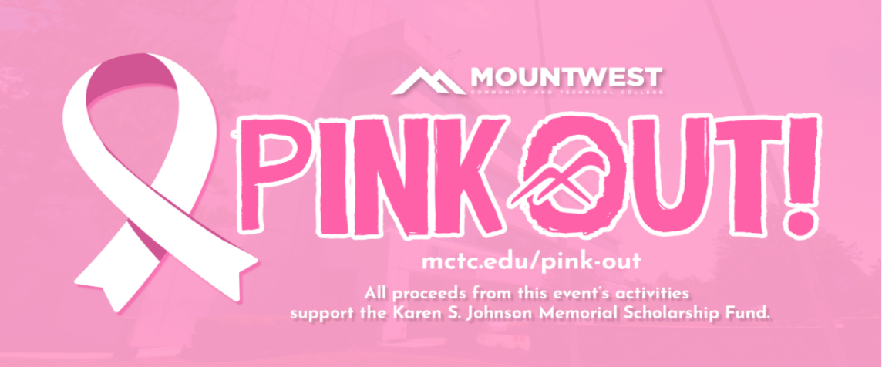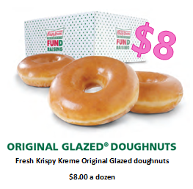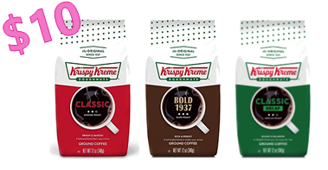

**12 oz. Bags of Krispy Kreme Signature Coffee, $10.00 a bag.**

**Available in Classic, Bold 1937, or Decaf**

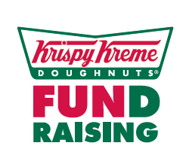

Please submit orders to Jennifer Porter - Martin190@mctc.edu - Room 225

Coffee & Doughnuts delivered to campus, Wednesday morning, October 27th --  Orders must be placed and paid for by Friday, October 22nd

|  |  |  |  |  |  |  |
| --- | --- | --- | --- | --- | --- | --- |
| **Name** | **Best Form of Contact** | **Classic Coffee** | **Bold Coffee** | **Decaf Coffee** | **Dozen Doughnuts** | **Total Paid** |
|  |  |  |  |  |  |  |
|  |  |  |  |  |  |  |
|  |  |  |  |  |  |  |
|  |  |  |  |  |  |  |
|  |  |  |  |  |  |  |